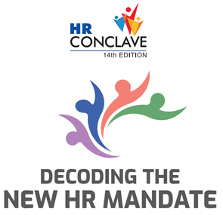

**REGISTRATION FORM**

09-10 December 2024

|  |  |  |  |  |
| --- | --- | --- | --- | --- |
| **No.** | **Name** | **Designation** | **Email** | **Mobile** |
| 1 |  |  |  |  |
| 2 |  |  |  |  |
| 3 |  |  |  |  |
| 4 |  |  |  |  |
| 5 |  |  |  |  |

# Nominated by:

Name: ……………………………………………………………………………………….…… Designation: ……………………………………………………………..…………….

E mail: ……………………………………………………………………………………….…… Mobile: ………………………………………………………………………………..….

Organization: ………………………..……..…………………………………………….………………………………………………………………………………………………..………

CII Membership No: ………………………..…………….…………… Organization GST No: …………………………………………………………………………..………..

Organization TAN No: …………………………………………….………………………….Organization PAN No: ………………………………………………………………

Address : …………………………………..………………..………………………………………………………………………………………………………………………………….…….

City: ……………………………..…………..…………………… Pin: ……………………………………………….. Telephone: ……………………………………………….………

|  |  |
| --- | --- |
| **CATEGORY** | **REGISTRATION FEE** |
| CII Member | INR 15000/- per person |
| Non-Member | INR 18000/- per person |
| **GST of 18% applicable**  **NOTE:**   * For Group participation of 3 persons & more, there will be a discount of 10% per delegate. * Pre- Registration is mandatory. * Participant fee once paid is non-refundable; however, change in nomination(s) is acceptable. * Payment is to be made before the commencement of the event.   **CANCELLATION POLICY:**   * No charges applicable for cancellations done before 48 hours from the commencement of the event. * 50% of the delegate fee will be charged for cancellations done within 48 Hours from the commencement of the event | |

**Contact Details**

# Naghma Akhtar | Confederation of Indian Industry (CII)

CII-Suresh Neotia Centre of Excellence for Leadership, DC-36, Sector – I, Salt Lake, Kolkata 700 064

**T**: + 91- 33 – 66140153 | **M**: +91 8013598139 | **E :** [naghma.akhtar@cii.in](mailto:naghma.akhtar@cii.in)